**Project Title: A CRM APPLICATION FOR LAPTOP RENTALS**

# Project Overview

This project is focused on developing a CRM solution for managing rental laptops, designed to address the challenges of inventory tracking, customer interactions, and rental agreements. The goal is to deliver a comprehensive solution by leveraging Salesforce as the platform for managing customer relationships and automating rental processes. Through this project, we aim to enhance operational efficiency, improve user experience, and ensure data accuracy, supporting the long-term goals of the organization in the competitive rental market.

# Objectives

### **Object Creation:**

Salesforce objects are database tables that permit you to store data that is specific to an organization.What are the types of Salesforce objects  
Salesforce objects are of two types:

1. Standard Objects: Standard objects are the kind of objects that are provided by salesforce.com such as users, contracts, reports, dashboards, etc.
2. Custom Objects: Custom objects are those objects that are created by users. They supply information that is unique and essential to their organization. They are the heart of any application and provide a structure for sharing data.

Click on gear icon >> click setup.

**To create an object:**

1. From the setup page >> Click on Object Manager >> Click on Create >> Click on Custom Object.
2. On Custom object defining page:
3. Enter the label name, plural label name, click on Allow reports, Allow search.
4. Click on Save.

**Create Total Laptops Object:**

1.From the setup page >> Click on Object Manager >> Click on Create >> Click on Custom Object.

1) Enter the label name>> Total Laptops

2) Plural label name>> Total Laptops

3) Enter Record Name Label and Format

   Record Name >>Total Laptops

     Data Type >> Text

1. Click on Allow reports,Allow search  and Track Field History,
2. Allow search >> Save

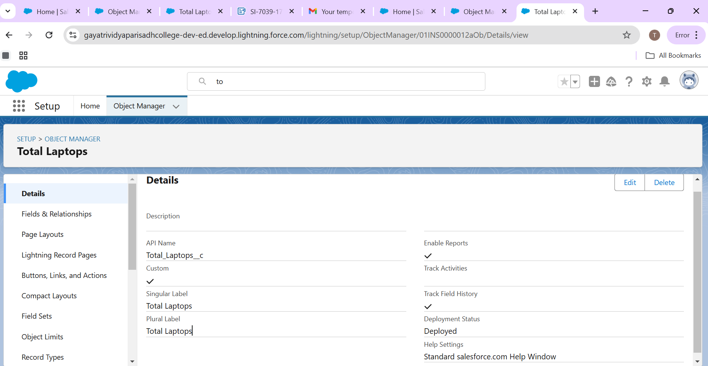

Similarly the custom objects are created consumer,Laptop Bookings and Billing process.

**Create Consumer Object:**

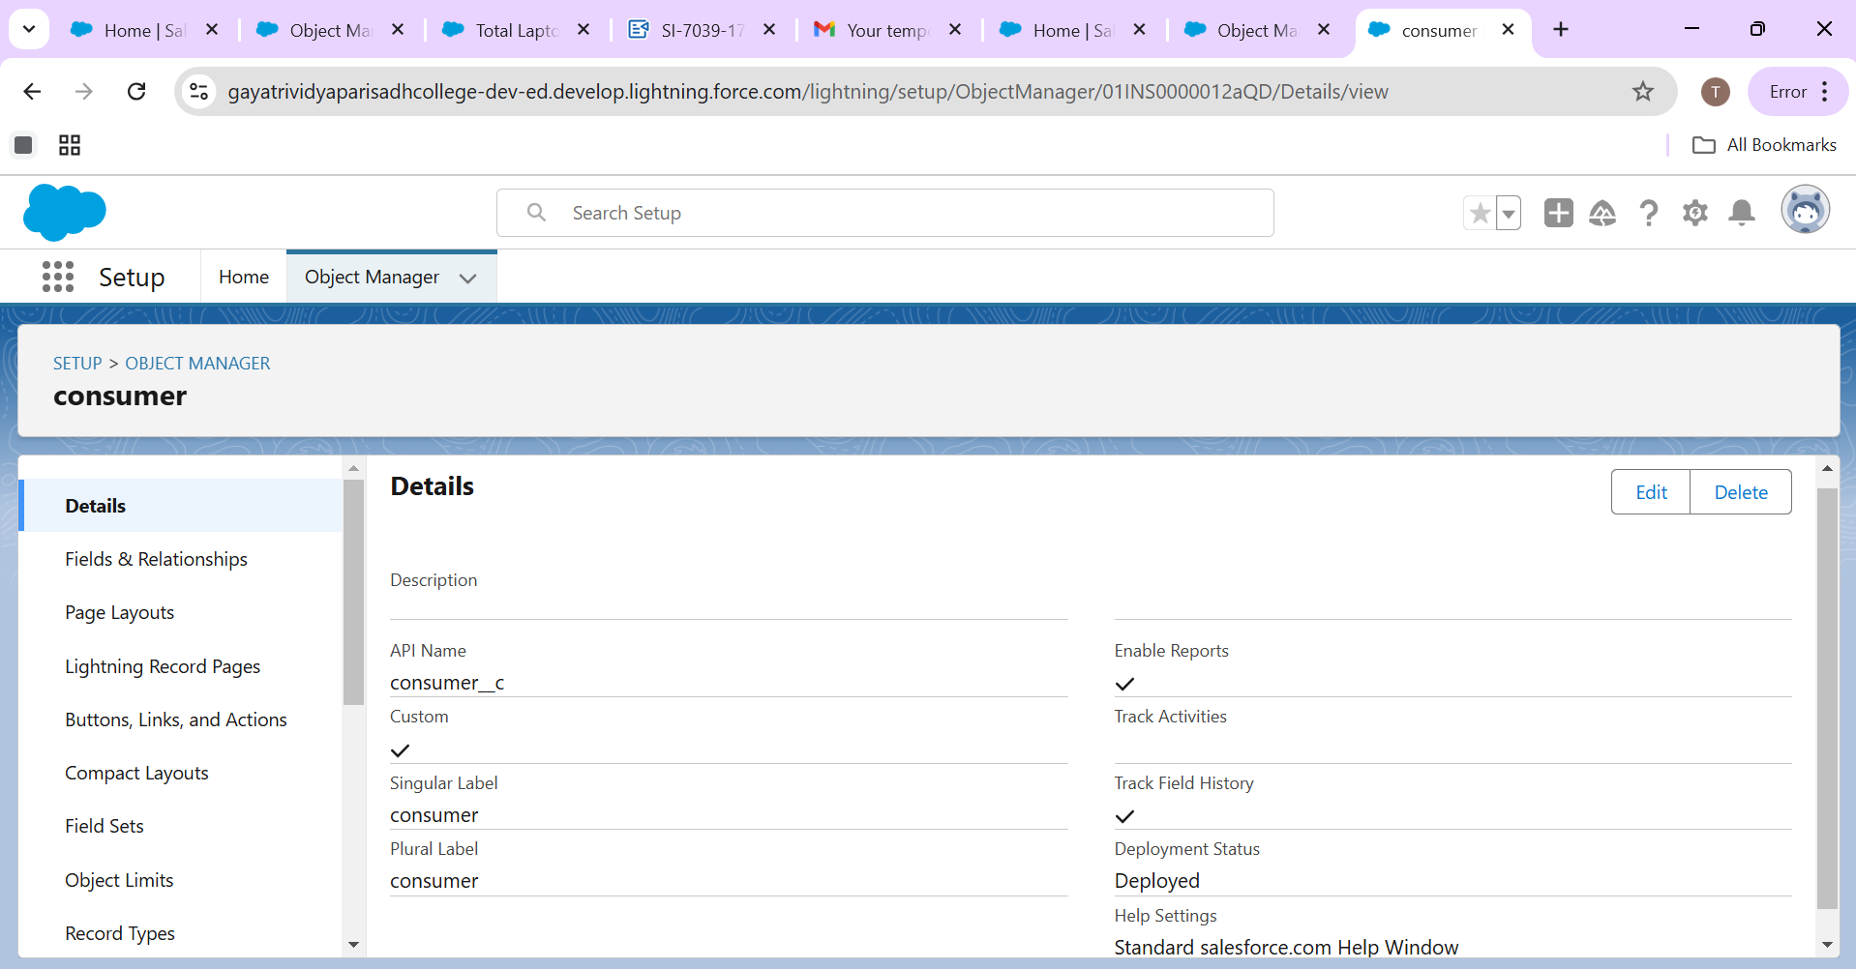

**Create Laptop Bookings:**

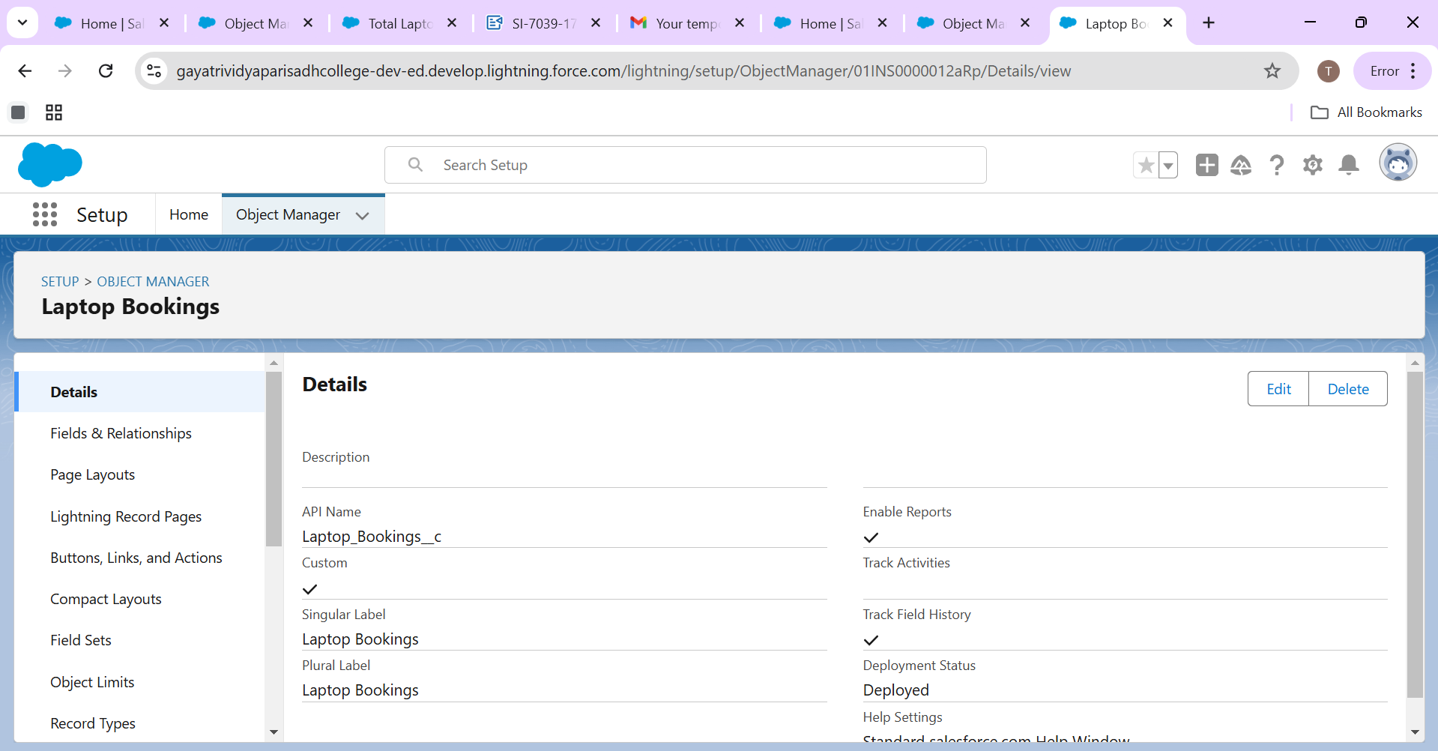

**Create Billing Process:**

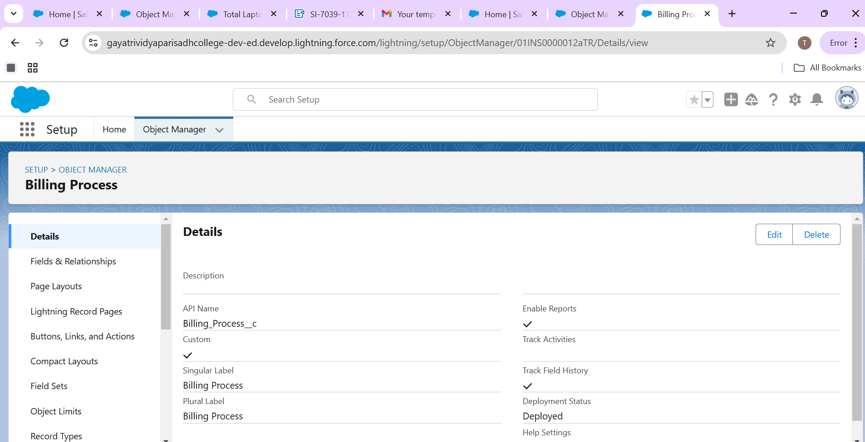

**Tabs:**

A tab is like a user interface that is used to build records for objects and to view the records in the objects.

**Types of Tabs:**

**1.Custom Tabs**

Custom object tabs are the user interface for custom applications that you build in salesforce.com. They look and behave like standard salesforce.com tabs such as accounts, contacts, and opportunities.

**2.Web Tabs:** Web Tabs are custom tabs that display web content or applications embedded in the salesforce.com window. Web tabs make it easier for your users to quickly access content and applications they frequently use without leaving the salesforce.com application.

**3.Visualforce Tabs**

Visualforce Tabs are custom tabs that display a Visualforce page. Visualforce tabs look and behave like standard salesforce.com tabs such as accounts, contacts, and opportunities.

**4.Lightning Component Tabs**

Lightning Component tabs allow you to add Lightning components to the navigation menu in Lightning Experience and the mobile app.

**5.Lightning Page Tabs**

Lightning Page Tabs let you add Lightning Pages to the mobile app navigation menu.

Lightning Page tabs don't work like other custom tabs. Once created, they don't show up on the All Tabs page when you click the Plus icon that appears to the right of your current tabs. Lightning Page tabs also don't show up in the Available Tabs list when you customize the tabs for your apps.

1. Go to setup page >> Type Tabs in Quick Find bar >> click on tabs >> New (under custom object tab)
2. Select Object(Total Laptops) >> Select the tab style >> Next (Add to profiles page) keep it as default >> Next (Add to Custom App)  uncheck the include tab .
3. Make sure that the Append tab to users' existing personal customizations is checked.
4. Click save.

**Activity 2: Creating Remaining Tabs**Now create the Tabs for the remaining Objects, they are “consumer,Laptop Booking,Billing process”.

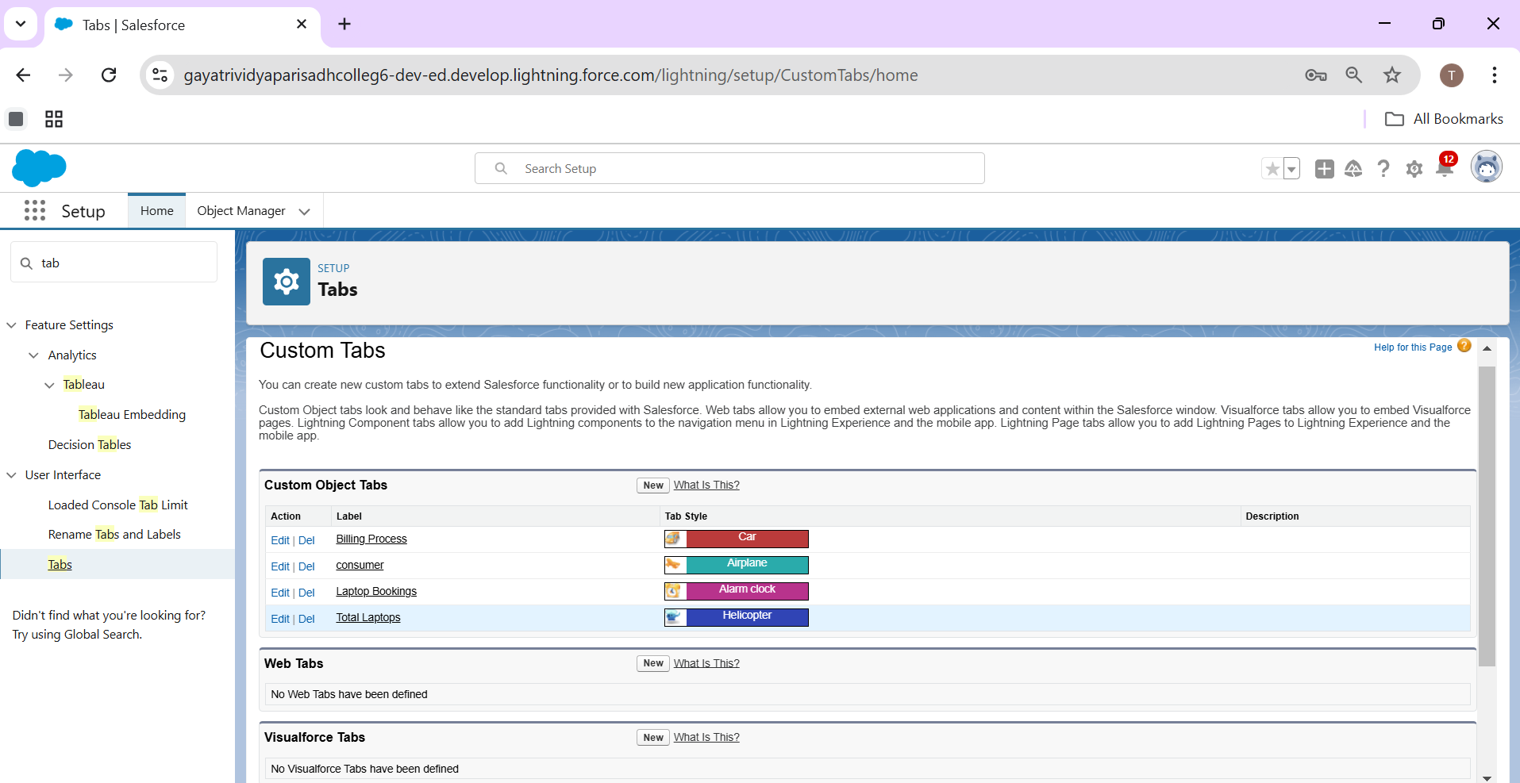

# 

# Salesforce Key Features and Concepts Utilized

This highlights the main functionalities and concepts applied within the Salesforce project.

**The Lightning App:**

An app is a collection of items that work together to serve a particular function. In Lightning Experience, Lightning apps give your users access to sets of objects, tabs, and other items all in one convenient bundle in the navigation bar.

Lightning apps let you brand your apps with a custom color and logo. You can even include a utility bar and Lightning page tabs in your Lightning app. Members of your org can work more efficiently by easily switching between apps**.**

**Create a Lightning App**

To create a lightning app page:

1.Go to setup page >> search “app manager” in quick find >> select “app manager” >> click on New lightning App.

2.Fill the app name in app details as LAPTOP RENTALS >>Next  >> (App option page) keep it as default >> Next >> (Utility Items) keep it as default >> Next.

3.Upload a photo that is related to your app.

To Add Navigation Items:  
4.Select the items (Total Laptops,consumer,Laptop Booking,Billing Process) from the search bar and move it using the arrow button >> Next.

5.To Add User Profiles:

6.Search profiles (System administrator) in the search bar >> click on the arrow button >> save & finish.

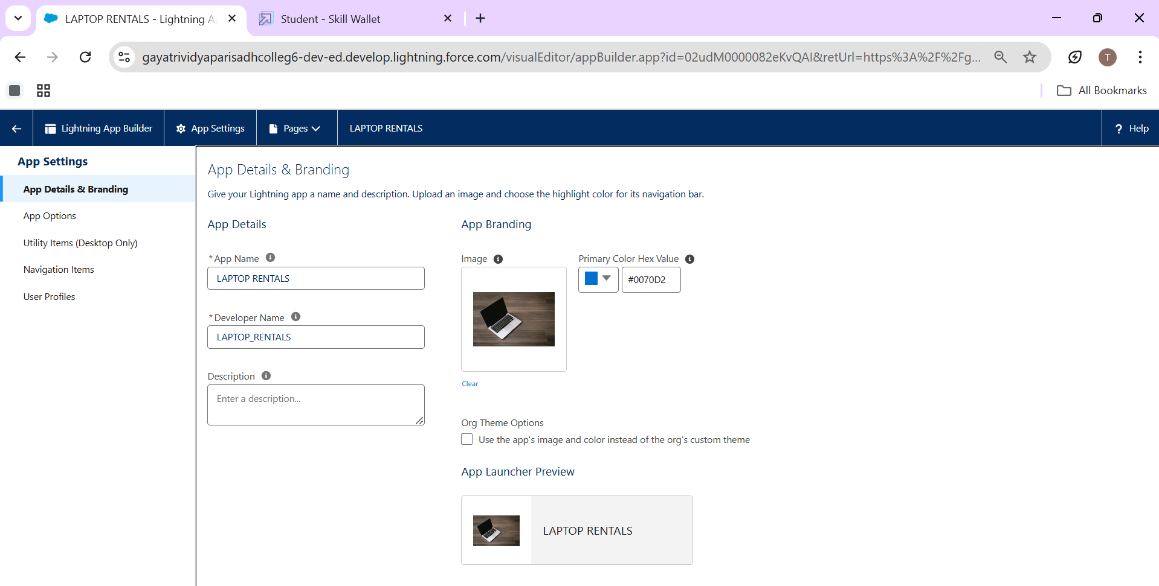

# Detailed Steps to Solution Design

When we talk about Salesforce, Fields represent the data stored in the columns of a relational database. It can also hold any valuable information that you require for a specific object. Hence, the overall searching, deletion, and editing of the records become simpler and quicker.

Types of Fields

Standard Fields

Custom Fields

Standard Fields:

As the name suggests, the Standard Fields are the predefined fields in Salesforce that perform a standard task. The main point is that you can’t simply delete a Standard Field until it is a non-required standard field. Otherwise, users have the option to delete them at any point from the application freely. Moreover, we have some fields that you will find common in every Salesforce application. They are,

>>Created By

>>Owner

>> Last Modified

>> Field Made During object Creation

Custom Fields:

On the other side of the coin, Custom Fields are highly flexible, and users can change them according to requirements. Moreover, each organizer or company can use them if necessary. It means you need not always include them in the records, unlike Standard fields. Hence, the final decision depends on the user, and he can add/remove Custom Fields of any given form.

**Creating the field in consumer object**

**To create fields in an object:**

1. Go to setup >> click on Object Manager >> type object name(consumer) in search bar >> click on the object.
2. Now click on “Fields & Relationships” >> New
3. Select Data Type as a “Phone”
4. Click on next

* Fill the Above as following:
* Field Label: Phone number
* Field Name : gets auto generated
* Click the required option checkbox.

Click on Next >> Next >> Save and new.

**To create another fields in an object:**

1. Go to setup >> click on Object Manager >> type object name(consumer) in search bar >> click on the object.
2. Now click on “Fields & Relationships” >> New
3. Select Data type as a “Email” and Click on Next
4. Fill the Above as following:

* Field Label: Email
* Field Name :It’s  gets auto generated
* Click on Next >> Next >> Save and new.

**To create another fields in an object:**

1. Go to setup >> click on Object Manager >> type object name(consumer) in search bar >> click on the object.
2. Now click on “Fields & Relationships” >> New
3. Select Data type as a “Text Area” and Click on Next
4. Fill the Above as following:

* Field Label:  Address
* Field Name : It’s gets auto generated
* Select Required field.
* Click on Next >> Next >> Save and new.

**To create another fields in an object:**

1. Go to setup >> click on Object Manager >> type object name(consumer) in search bar >> click on the object.
2. Now click on “Fields & Relationships” >> New
3. Select Data type as a “Picklist” and Click on Next
4. Fill the Above as following:

* Field Label: consumer Status
* Value - Select enter values with each value separated by a new line
* Student
* Employee
* Others
* Select required
* Field Name :It’s gets auto generated
* Click on Next >> Next >> Save and new.  
   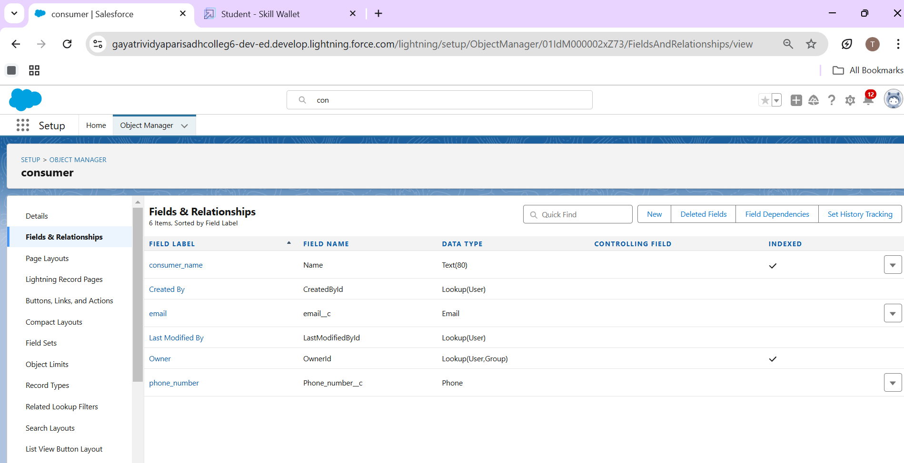

Similarly create Laptop Booking object, Billing Process object and Total Laptops objects.

**Creating the field in Laptop Booking Objects:**

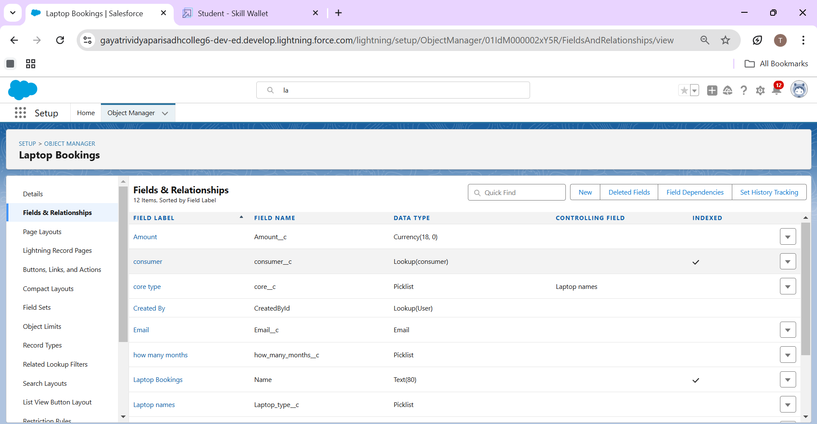

**Creating the field in Billing Process Objects:**

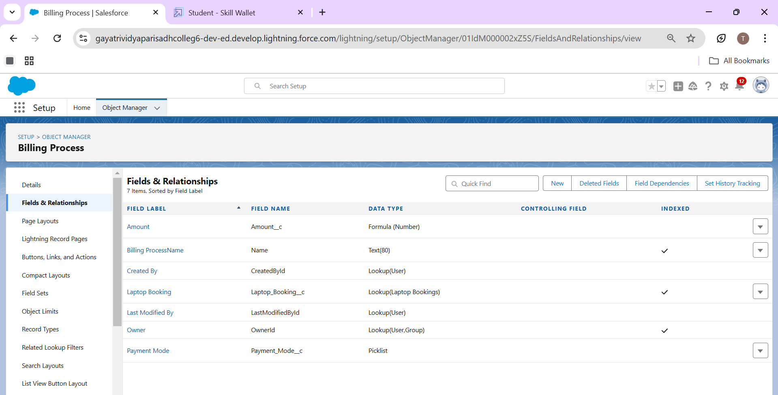

**Creating the field in Total Laptops Objects:**

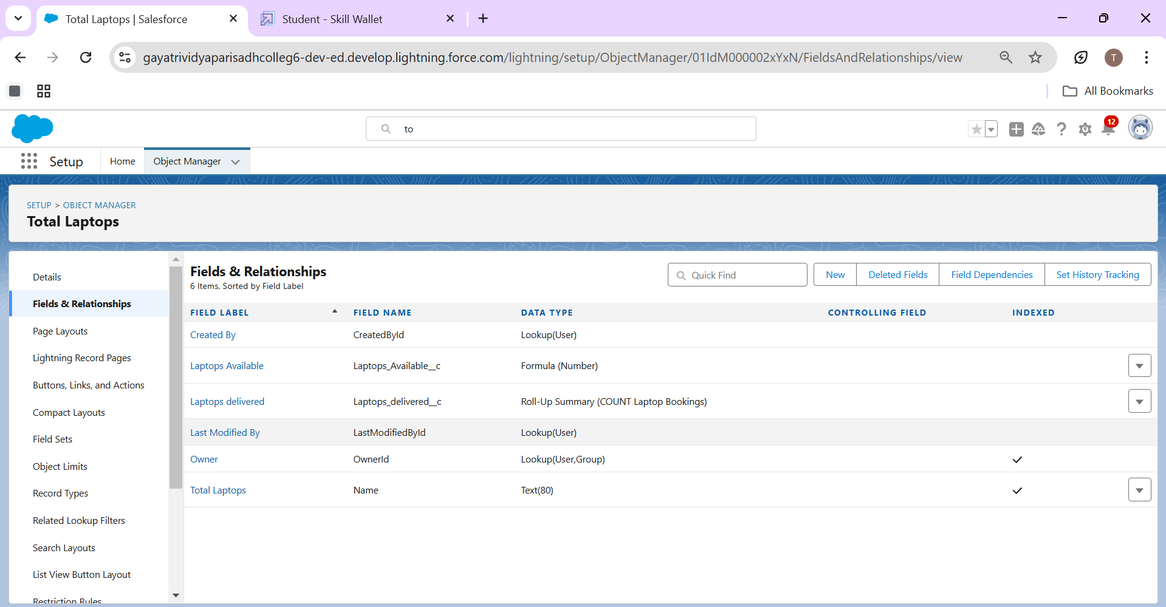

# Testing and Validation

**Validation rule**

Validation rules are applied when a user tries to save a record and are used to check if the data meets specified criteria. If the criteria are not met, the validation rule triggers an error message and prevents the user from saving the record until the issues are resolved.

Improve the quality of your data using validation rules. Validation rules verify that the data a user enters in a record meets the standards you specify before the user can save the record. A validation rule can contain a formula or expression that evaluates the data in one or more fields and returns a value of “True” or “False”. Validation rules also include an error message to display to the user when the rule returns a value of “True” due to an invalid value.

**Creating the validation rule for phone number field in consumer object**

1. Go to the setup page >> click on object manager >> From drop down click edit for  consumer  object.
2. Click on the validation rule >> click New.
3. Enter the Rule name as “Phonenumberoremailblankrule ”.
4. Enter the description as “phone number and email number should not be blank”.
5. Enter the formula as “OR( ISBLANK( phone_number__c ) , ISBLANK( email__c ) )” and check the syntax.

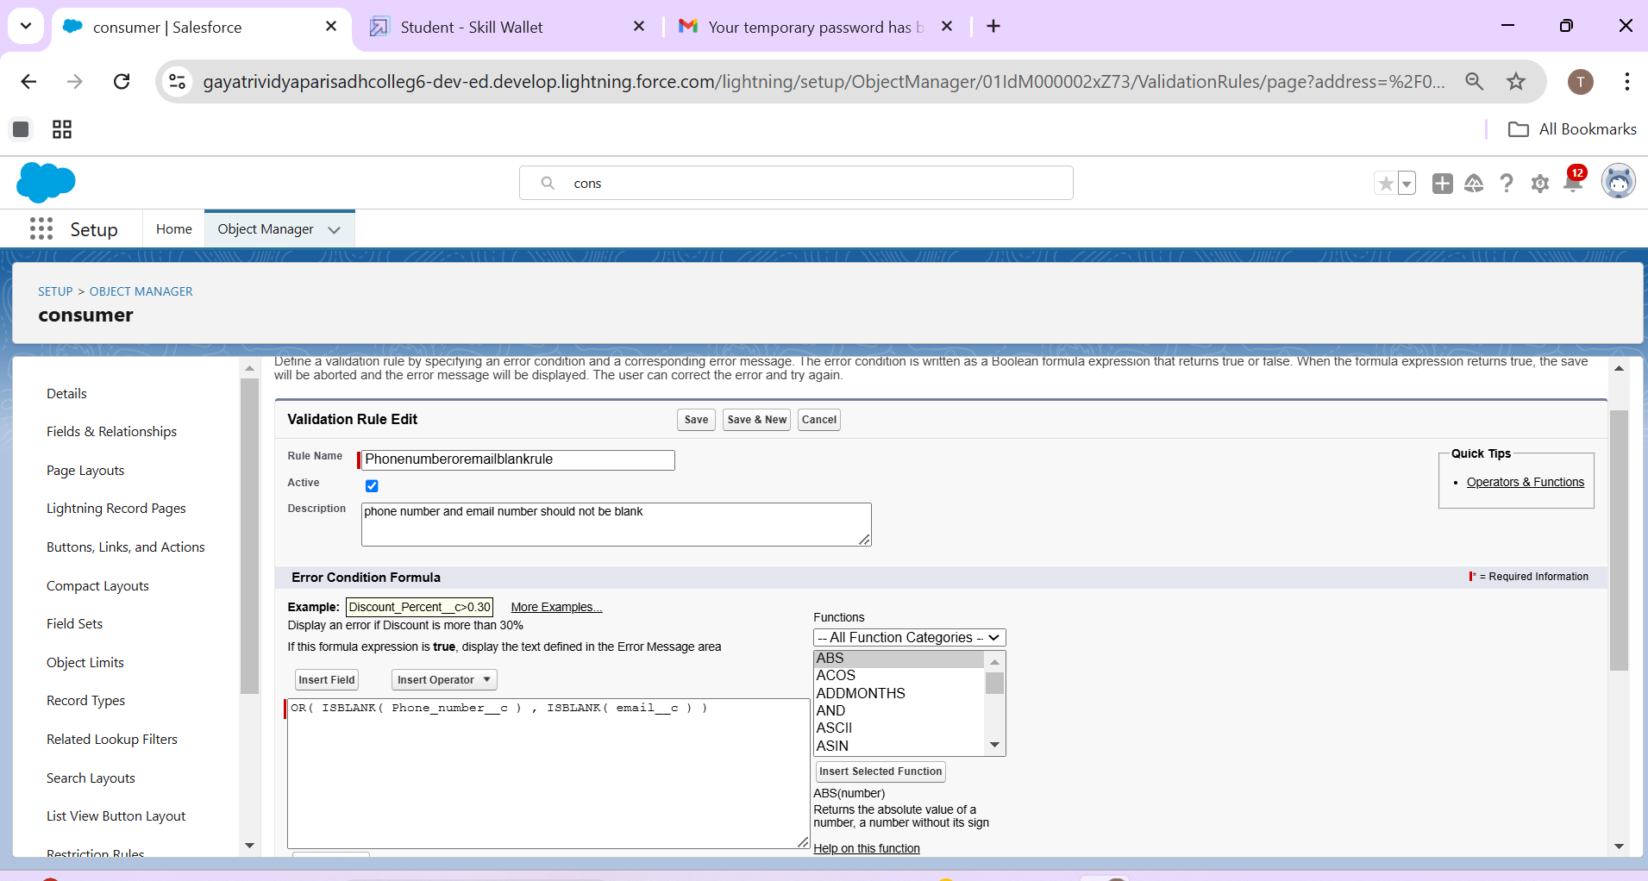

1. Save the validation rule.

**Flows**

In Salesforce, a flow is a powerful tool that allows you to automate business processes, collect and update data, and guide users through a series of screens or steps. Flows are built using a visual interface and can be created without any coding knowledge.

In Salesforce, "flows" typically refer to Salesforce Flow, which is a powerful automation tool that allows you to create custom, automated processes in your Salesforce org without writing code. Salesforce Flow is a point-and-click tool that enables you to design and automate complex business processes, collect data, and interact with users in a visual interface. There are different types of flows in Salesforce, including:

Screen Flows: These are used to guide users through a series of screens to collect or display information. Screen Flows are often used for data entry and updates.

Autolaunched Flows: These are flows that are triggered by events, such as when a record is created or updated. They don't require user interaction and can be used for background automation.

Flow Builder: Flow Builder is the visual interface used to create flows. It allows you to design flows by adding elements, like screens, logic, and actions, using a drag-and-drop approach.

Flow Templates: Salesforce provides a library of pre-built flow templates that you can use as a starting point for your own flows. These templates cover a variety of use cases, from simple to complex.

Scheduled Flows: These are flows that you can schedule to run at specific times or intervals. They are often used for automating recurring tasks.

Flow Elements: Flow Builder offers various elements that you can use to create flows, such as variables, decisions, loops, and more. These elements allow you to build sophisticated logic into your flows.

Subflows: Subflows are reusable flow elements that you can incorporate into multiple flows, making it easier to manage and maintain complex processes.

Record-Triggered Flows: These are flows that are triggered when records meet specified criteria. They are often used for automating record updates and related actions.

Why do we need to create a flow:

To get the Amount Field automatic by the selection of laptop types the Amount is generated Automatically in the amount field.

Activity -

1. Go to setup >>type Flow in quick find box >> Click on the Flow and Select the New Flow
2. Select the Record-triggered flow and Click on Create.
3. Select the Object as a Laptop  Booking in the Drop down list.
4. Select the Trigger Flow when: “A record is Created or Updated”.
5. Select the Optimize the flow for: “Actions and Related Records” and Click on Done.
6. Under the Record-triggered Flow Click on “+” Symbol and In the Drop down List select the “Decision Element”.
7. Enter the Details Label: Field should be Update, API name: Gets Automatically Generated.
8. Enter the Outcome Details Label: dell , Outcome API name: Gets Automatically Generated.

* Resource: Select Record.Laptop booking__c.
* Operator: Select Equals.
* Value: Select dell
* Add the same outcome order  to acer , hp,mac.
* Click done.

1. Go to flow page
2. Beside  dell there is a symbol   ‘+’   click on that.
3. Again select decision
4. Enter the Details Label: Field should  Update(any one u want), API name: Gets Automatically Generated.
5. select the Outcome Details Label: dell core i3 , Outcome API name: Gets Automatically Generated.

* Resource:   Select Record.core type.
* Operator:   Select Equals.
* Value: Select core i3.
* Then again click the symbol   ‘+’  outcome details

1. select the Outcome ‘+’     Details Label: dell core i5 , Outcome API name: Gets Automatically Generated.

* Resource: Select Record.core type.
* Operator: Select Equals.
* Value: Select core i5.
* Then again click the symbol’+’ outcome details

1. Enter the Outcome Details Label: dell core i7 , Outcome API name: Gets Automatically Generated.

* Resource: Select Record.core type.
* Operator: Select Equals.
* Value: Select core i7.

1. Click done.
2. So go to the flow page select ‘+’ after core i3 then again select the decision.
3. Enter the Details Label: months selected , API name: Gets Automatically Generated.
4. Enter the Outcome Details Label: dell 1(i3) , Outcome API name: Gets Automatically Generated.

* Resource: Select Record.how many months.
* Operator: Select Equals.
* Value: 1.

1. Enter the Outcome Details Label: dell 2(i3) , Outcome API name: Gets Automatically Generated.

* Resource: Select Record.how many months.
* Operator: Select Equals.
* Value: Select 2..

1. Click ‘+’ outcome details
2. Enter the Outcome Details Label: dell 3(i3) , Outcome API name: Gets Automatically Generated.

* Resource: Select Record.how many months.
* Operator: Select Equals.
* Value: Select 3..

1. Click ‘+’ outcome details
2. Enter the Outcome Details Label: dell 4(i3) , Outcome API name: Gets Automatically Generated.

* Resource: Select Record.how many months.
* Operator: Select Equals.
* Value: Select 4..

1. Click ‘+’ outcome details
2. Enter the Outcome Details Label: dell 5(i3) , Outcome API name: Gets Automatically Generated.

* Resource: Select Record.how many months.
* Operator: Select Equals.
* Value: Select 4.

1. Follow the above picture you will understand.
2. After dell 1(i3) there is ‘+’ symbol like dell 2(i3),dell 3(i3),dell 4(i3),dell 5(i3).
3. Click on ‘+’ then select update records
4. Enter the Details Label: one month of dell i3 rate , API name: Gets Automatically Generated.
5. Field:- Amount__c  , value:- for dell 1(i3)-1000,    dell 2(i3)-2000,    dell 3(i3)-3000,   dell 4(i3)-4000,   dell 5(i3)-5000. Follow for all these finally
6. Click done.
7. Enter the Details Label: months selected , API name: Gets Automatically Generated.
8. Enter the Outcome Details Label: dell 1(i7) , Outcome API name: Gets Automatically Generate

* Resource: Select Record.how many months.
* Operator: Select Equals.
* Value: 1.

1. Enter the Outcome Details Label: dell 2(i7) , Outcome API name: Gets Automatically Generated.

* Resource: Select Record.how many months.
* Operator: Select Equals.
* Value: Select 2..

1. Click ‘+’ outcome details
2. Enter the Outcome Details Label: dell 3(i7) , Outcome API name: Gets Automatically Generated.

* Resource: Select Record.how many months.
* Operator: Select Equals.
* Value: Select 3..

1. Click ‘+’ outcome details
2. Enter the Outcome Details Label: dell 4(i7) , Outcome API name: Gets Automatically Generated.

* Resource: Select Record.how many months.
* Operator: Select Equals.
* Value: Select 4.

1. Click ‘+’ outcome details
2. Enter the Outcome Details Label: dell 5(i7) , Outcome API name: Gets Automatically Generated.

* Resource: Select Record.how many months.
* Operator: Select Equals.
* Value: Select 5.

1. Follow the above picture you will understand.
2. After dell 1(i7) there is ‘+’ symbol like dell 2(i7),dell 3(i7),dell 4(i7),dell 5(i7).
3. Click on ‘+’ then select update records
4. Enter the Details Label: one month of dell i5 rate , API name: Gets Automatically Generated.
5. Field:- Amount__c  , value:- for dell 1(i7)-2000,    dell 2(i7)-4000,    dell 3(i7)-6000,   dell 4(i7)-8000,   dell 5(i7)-10000. Follow for all these finally
6. Click done.

**creating flow on acer laptop**

1. Go to flow page
2. Beside  acer  there is a symbol   ‘+’   click on that.
3. Again select decision
4. Enter the Details Label: Field is Update, API name: Gets Automatically Generated.
5. select the Outcome Details Label: acer core i3 , Outcome API name: Gets Automatically Generated.

* Resource:   Select Record.core type.
* Operator:   Select Equals.
* Value: Select core i3.

Click done.

1. Go to flow page
2. Beside  dell there is a symbol   ‘+’   click on that.
3. Again select decision

Enter the Details Label: months selected , API name: Gets Automatically Generated.

1. Enter the Outcome Details Label: acer 1(i3) , Outcome API name: Gets Automatically Generated.

* Resource: Select Record.how many months.
* Operator: Select Equals.
* Value: 1.

1. Enter the Outcome Details Label: acer 2(i3) , Outcome API name: Gets Automatically Generated.

* Resource: Select Record.how many months.
* Operator: Select Equals.
* Value: Select 2..

1. Click ‘+’ outcome details
2. Enter the Outcome Details Label: acer 3(i3) , Outcome API name: Gets Automatically Generated.

* Resource: Select Record.how many months.
* Operator: Select Equals.
* Value: Select 3..

1. Click ‘+’ outcome details
2. Enter the Outcome Details Label: acer 4(i3) , Outcome API name: Gets Automatically Generated.

* Resource: Select Record.how many months.
* Operator: Select Equals.
* Value: Select 4.

1. Click ‘+’ outcome details
2. Enter the Outcome Details Label: acer 5(i3) , Outcome API name: Gets Automatically Generated.

* Resource: Select Record.how many months.
* Operator: Select Equals.
* Value: Select 5.

Click done.

1. After acer 1(i3) there is ‘+’ symbol like acer 2(i3),acer 3(i3),acer 4(i3),acer 5(i3).
2. Click on ‘+’ then select update records
3. Enter the Details Label: one month of acer i3 rate , API name: Gets Automatically Generated.
4. Field:- Amount__c  , value:- for acer 1(i3)-900,    acer 2(i3)-1800,    acer 3(i3)-2700,   acer 4(i3)-3600,   acer  5(i3)-4800. Follow for all these finally
5. Click done.

**creating a flow on hp laptop**

1. Go to flow page
2. Beside  hp  there is a symbol   ‘+’   click on that.
3. Again select decision
4. Enter the Details Label: Field is Update, API name: Gets Automatically Generated.
5. select the Outcome Details Label: hp core i5 , Outcome API name: Gets Automatically Generated.

* Resource:   Select Record.core type.
* Operator:   Select Equals.
* Value: Select hp i5.

1. Go to flow page
2. Beside  hp there is a symbol   ‘+’   click on that.
3. Again select decision
4. Enter the Details Label: hp field should be updated , API name: Gets Automatically Generated.
5. Enter the Outcome Details Label: hp 1(i5) , Outcome API name: Gets Automatically Generated.

* Resource: Select Record.how many months.
* Operator: Select Equals.
* Value: 1.

1. Enter the Outcome Details Label: hp 2(i5) , Outcome API name: Gets Automatically Generated.

* Resource: Select Record.how many months.
* Operator: Select Equals.
* Value: Select 2..

1. Click ‘+’ outcome details
2. Enter the Outcome Details Label: hp 3(i5) , Outcome API name: Gets Automatically Generated.

* Resource: Select Record.how many months.
* Operator: Select Equals.
* Value: Select 3..

1. Click ‘+’ outcome details
2. Enter the Outcome Details Label: hp 4(i5) , Outcome API name: Gets Automatically Generated.

* Resource: Select Record.how many months.
* Operator: Select Equals.
* Value: Select 4.

1. Click ‘+’ outcome details
2. Enter the Outcome Details Label: hp 5(i5) , Outcome API name: Gets Automatically Generated.

* Resource: Select Record.how many months.
* Operator: Select Equals.
* Value: Select 5.

Click on done.

1. After hp 1(i5) there is ‘+’ symbol like hp 2(i5), hp 3(i5), hp 4(i5),hp 5(i5).
2. Click on ‘+’ then select update records
3. Enter the Details Label: one month of hp i5 rate , API name: Gets Automatically Generated.
4. Field:- Amount__c  , value:- for hp 1(i5)-1700,    hp 2(i5)-3400,    hp 3(i5)-5100,   hp 4(i5)-6800,   hp  5(i5)-8500. Follow for all these finally

Click done.

**creating a flow on mac laptop**

1. Go to flow page
2. Beside  mac  there is a symbol   ‘+’   click on that.
3. Again select decision
4. Enter the Details Label: mac should be  Updated, API name: Gets Automatically Generated.
5. select the Outcome Details Label: mac laptop , Outcome API name: Gets Automatically Generated.

* Resource:   Select Record.core type.
* Operator:   Select Equals.
* Value: Select Bionic Chip.

Click done.

1. Go to flow page
2. Beside  Mac  there is a symbol   ‘+’   click on that.
3. Again select decision
4. Enter the Details Label:Mac months selected , API name: Gets Automatically Generated.
5. Enter the Outcome Details Label:  mac bionic chip(1) , Outcome API name: Gets Automatically Generated.

* Resource: Select Record.how many months.
* Operator: Select Equals.
* Value: 1.

1. Enter the Outcome Details Label: mac bionic chip(1) , Outcome API name: Gets Automatically Generated.

* Resource: Select Record.how many months.
* Operator: Select Equals.
* Value: Select 2..

1. Click ‘+’ outcome details
2. Enter the Outcome Details Label: mac bionic chip(1) , Outcome API name: Gets Automatically Generated.

* Resource: Select Record.how many months.
* Operator: Select Equals.
* Value: Select 3..

1. Click ‘+’ outcome details
2. Enter the Outcome Details Label: mac bionic chip(1) , Outcome API name: Gets Automatically Generated.

* Resource: Select Record.how many months.
* Operator: Select Equals.
* Value: Select 4.

1. Click ‘+’ outcome details
2. Enter the Outcome Details Label: mac bionic chip(1) , Outcome API name: Gets Automatically Generated.

* Resource: Select Record.how many months.
* Operator: Select Equals.

Value: Select 5.

Click done.

1. After mac bionic chip(1) there is ‘+’ symbol like mac bionic chip(2), mac bionic chip(3), mac bionic chip(4),mac bionic chip(5).
2. Click on ‘+’ then select update records
3. Enter the Details Label: one month of mac rate , API name: Gets Automatically Generated.
4. Field:- Amount__c  , value:- for one month of mac bionic chip rate-1700,   two month of mac bionic chip rate-3400,    three month of mac bionic chip rate-5100,   four month of mac bionic chip rate-6800,   five  month of mac bionic chip rate-8500. Follow for all these finally

Click done.

**Flow Builder**

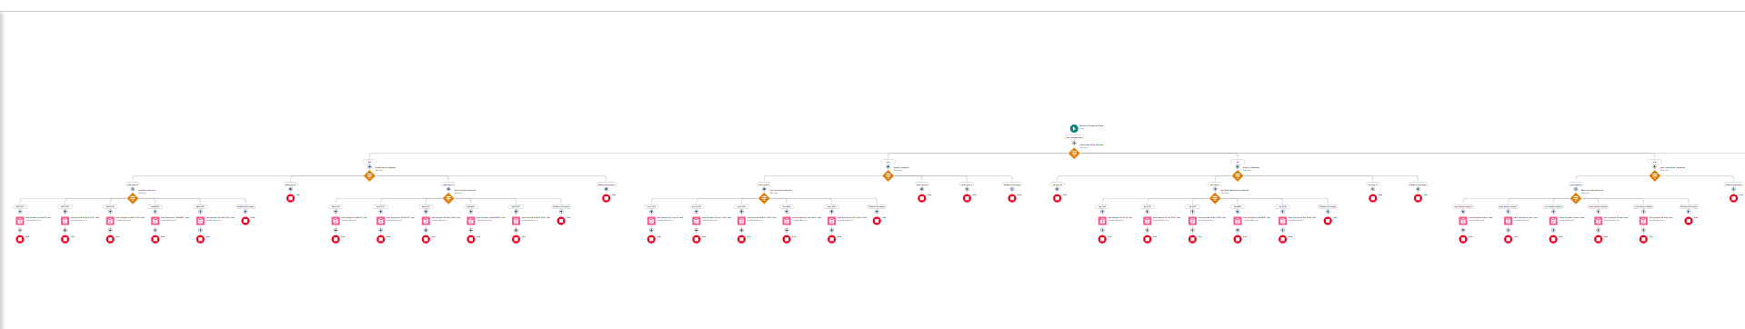

Label:- Laptop distributions, api name:- automatically filled

Save the flow and activate it.

**Apex OverView**

Apex is a strongly typed, object-oriented programming language that allows developers to execute flow and transaction control statements on the Lightning platform server in conjunction with calls to the Lightning Platform? API. Using syntax that looks like Java and acts like database stored procedures, Apex enables developers to add business logic to most system events, including button clicks, related record updates, and Visualforce pages. Apex code can be initiated by Web service requests and from triggers on objects.

It is as similar as java i.e, it also supports OOP( Object oriented programming) like Classes, objects, methods.

Creating Classes :

Apex classes are modeled on their counterparts in Java. You’ll define, instantiate, and extend classes, and you’ll work with interfaces, Apex class versions, properties, and other related class concepts.

* Class:

As in Java, you can create classes in Apex. A class is a template or blueprint from which objects are created. An object is an instance of a class.

* Object

Object is an instance of a class, where it can access all the properties that are present in a class i.e, variables and methods.

Steps to create a class in APEX:

1. Login to the trailhead account and navigate to the gear account in the top right corner.
2. Then we can see the Developer console. Click on the developer console and you will navigate to a new console window.
3. Then you can see many tools in the Toolbar of the new console window. Click on File, New and Apex Class.
4. Enter the name of the class to create a new class file.

**Access specifiers in Apex :**

Apex allows you to use the private, protected, public, and global access modifiers when defining methods and variables.

While triggers and anonymous blocks can also use these access modifiers, they aren’t as useful in smaller portions of Apex. For example, declaring a method as global in an anonymous block doesn’t enable you to call it from outside of that code.

**Private:**

This access modifier is the default, and means that the method or variable is accessible only within the Apex class in which it’s defined. If you don’t specify an access modifier, the method or variable is private.

**Protected:**

This means that the method or variable is visible to any inner classes in the defining Apex class, and to the classes that extend the defining Apex class. You can only use this access modifier for instance methods and member variables. This setting is strictly more permissive than the default (private) setting, just like Java.

Public :

This means that the method or variable is accessible by all Apex within a specific package. For accessibility by all second-generation (2GP) managed packages that share a namespace, use public with the @NamespaceAccessible annotation. Using the public access modifier in no-namespace packages implicitly renders the Apex code as @NamespaceAccessible.

Global

This means the method or variable can be used by any Apex code that has access to the class, not just the Apex code in the same application. This access modifier must be used for any method that must be referenced outside of the application, either in SOAP API or by other Apex code. If you declare a method or variable as global, you must also declare the class that contains it as global. This is how a new class is created :

**Triggers :**

A trigger is a set of Apex code that runs before or after DML(Data Manipulation Language) events.

A DML event could be a variety of data processing tasks that include the standard insert, update, and delete commands.

With Apex triggers, you can automate tasks that would otherwise be nearly impossible to accomplish using only the Salesforce user interface. Triggers enable you to create custom scripts that you can implement according to your needs, and the only limitation is your coding skills.

There are two Salesforce Apex trigger types:

Before triggers. These are helpful in cases that require a validation process before accepting a change. They run before any database changes. After triggers. These are helpful in cases where you need to modify your database records and when the necessary value is stored in other records. They run after any database changes. Both types will help you perform custom tasks and manage records effectively. They can help you perform bulk actions as they can handle several records simultaneously.

How to create a new trigger :

1. While still in the trailhead account, navigate to the gear icon in the top right corner.
2. Click on developer console and you will be navigated to a new console window.
3. Click on the File menu in the toolbar, and click on new- Trigger.
4. Enter the trigger name and the object to be triggered.

Syntax For creating trigger :

The syntax for creating trigger is :

Trigger [trigger name] on [object name]( Before/After event)

{

}

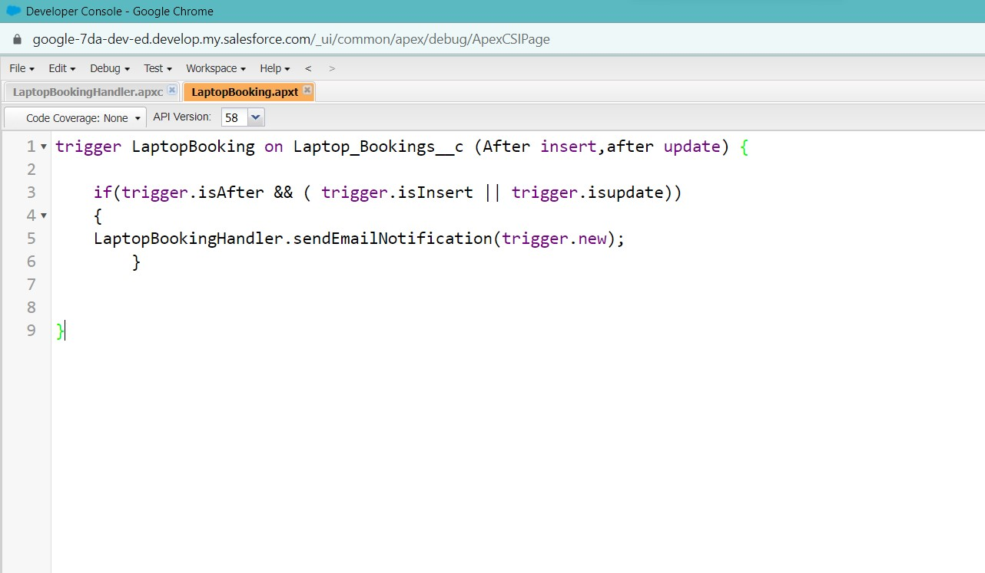

Trigger code:

trigger LaptopBooking on Laptop_Bookings__c (After insert,after update) {

    if(trigger.isAfter && ( trigger.isInsert || trigger.isupdate))

    {

    LaptopBookingHandler.sendEmailNotification(trigger.new);

        }

}

Note:- copy the API names

1.LaptopBooking - trigger name

2.Laptop_Bookings__c -as per your org(go to laptop bookings object and copy from that object api name).

Handler Class:

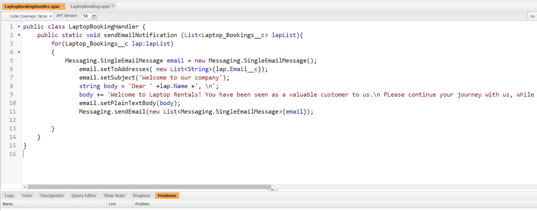

Code Snippet :

public class LaptopBookingHandler {

    public static void sendEmailNotification (List<Laptop_Bookings__c> lapList){

        for(Laptop_Bookings__c lap:lapList)

        {

            Messaging.SingleEmailMessage email = new Messaging.SingleEmailMessage();

                email.setToAddresses( new List<String>{lap.Email__c});

                email.setSubject('Welcome to our company');

             string body = 'Dear ' +lap.Name +', \n';

             body += 'Welcome to Laptop Rentals! You have been seen as a valuable customer to us.\n Please continue your journey with us, while we try to provide you with good quality resources. \n Laptop Amount = ' + lap.Amount__c + ' \n core type = '+lap.core__c +' \n Laptop type = '+lap.Laptop_type__c;

             email.setPlainTextBody(body);

                Messaging.sendEmail(new List<Messaging.SingleEmailMessage>{email});

        }

    }

}

Note:-

1.Class name:- LaptopBookingHandler

2.API Name:- Laptop_Bookings__c(as per your org go to laptop booking object and copy from that).

3.core__c (as per your org go to laptop booking object and copy from that).

4.Laptop_type__c.(as per your org go to laptop booking object and copy from that).

In this project , trigger is called whenever the particular record's sum exceeds the threshold i.e minimum business requirement value. Then the code in the trigger will get executed.

# Key Scenarios Addressed by Salesforce in the Implementation Project

**Report:**

Reports give you access to your Salesforce data. You can examine your Salesforce data in almost infinite combinations, display it in easy-to-understand formats, and share the resulting insights with others. Before building, reading, and sharing reports, review these reporting basics.

In Salesforce.com we can easily generate reports in different styles. And can create reports in a very short time and also schedule the reports. Salesforce provides a powerful suit of analytic tools to help you organize, view and analyze your data.

Types of Reports in Salesforce

Tabular

Summary

Matrix

Joined Reports

1. Tabula Reports: Simple listing of data without any subtotals. This type of reports provide you most basically to look at your data. Use tabular reports when you want a simple list or a list of items with a grand total.

Example: This type of reports are used to list all accounts, List of contacts, List of opportunities…..etc.….

2. Summary Reports: This type of reports provide a listing of data with groupings and sub totals. Use summary reports when you want subtotals based on the value of a particular field or when you want to create a hierarchically grouped report, such as sales organized by year and then by quarter.

Example: All opportunities for your team sub totaled by Sales Stage and Owner.

3. Matrix Reports: This type of reports allow you to group records both by row and by column. A comparison of related totals, with totals by both row and column. Use matrix reports when you want to see data by two different dimensions that aren’t related, such as date and product.

Example: Summarize opportunities by month vertically and by account horizontally.

4. Joined Reports: Blocks of related information in a single report. This type of reports enable you to adopt five different blocks to display different types of related data. Each block can own unique columns, summary fields, formulas, filters and sort order. Use joined reports to group and show data from multiple report types in different views.

Example: You can build a report to show opportunity, case and activity data for your accounts.

**Create Report**

1. Go to the app -click on the reports tab
2. Click New Report.

3.Select report type from category or from report type panel or from search panel “consumer with Laptop Bookings and total laptops” >> click on start report.

4.Customize your report

5.Add fields from left pane as shown below

Follow the above image group rows and columns.

6.Click the column drop down and select bucket list.

Click apply it.

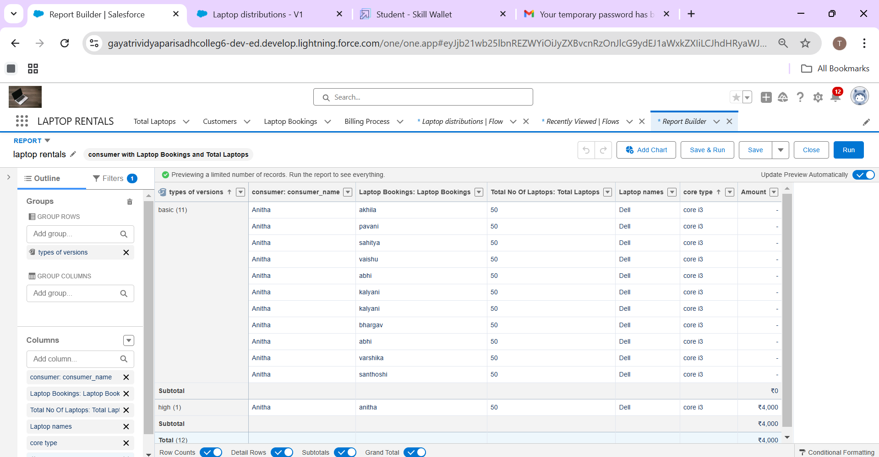

Follow the picture and save or run it.

**Dashboards**

Dashboards help you visually understand changing business conditions so you can make decisions based on the real-time data you’ve gathered with reports. Use dashboards to help users identify trends, sort out quantities, and measure the impact of their activities. Before building, reading, and sharing dashboards, review these dashboard basics.

1. Click on the app launcher and search for the dashboard.
2. Click on the dashboard tab.
3. Click the new folder, give the folder label as “total rent amount”.
4. Folder unique names will be auto populated.
5. Click save.

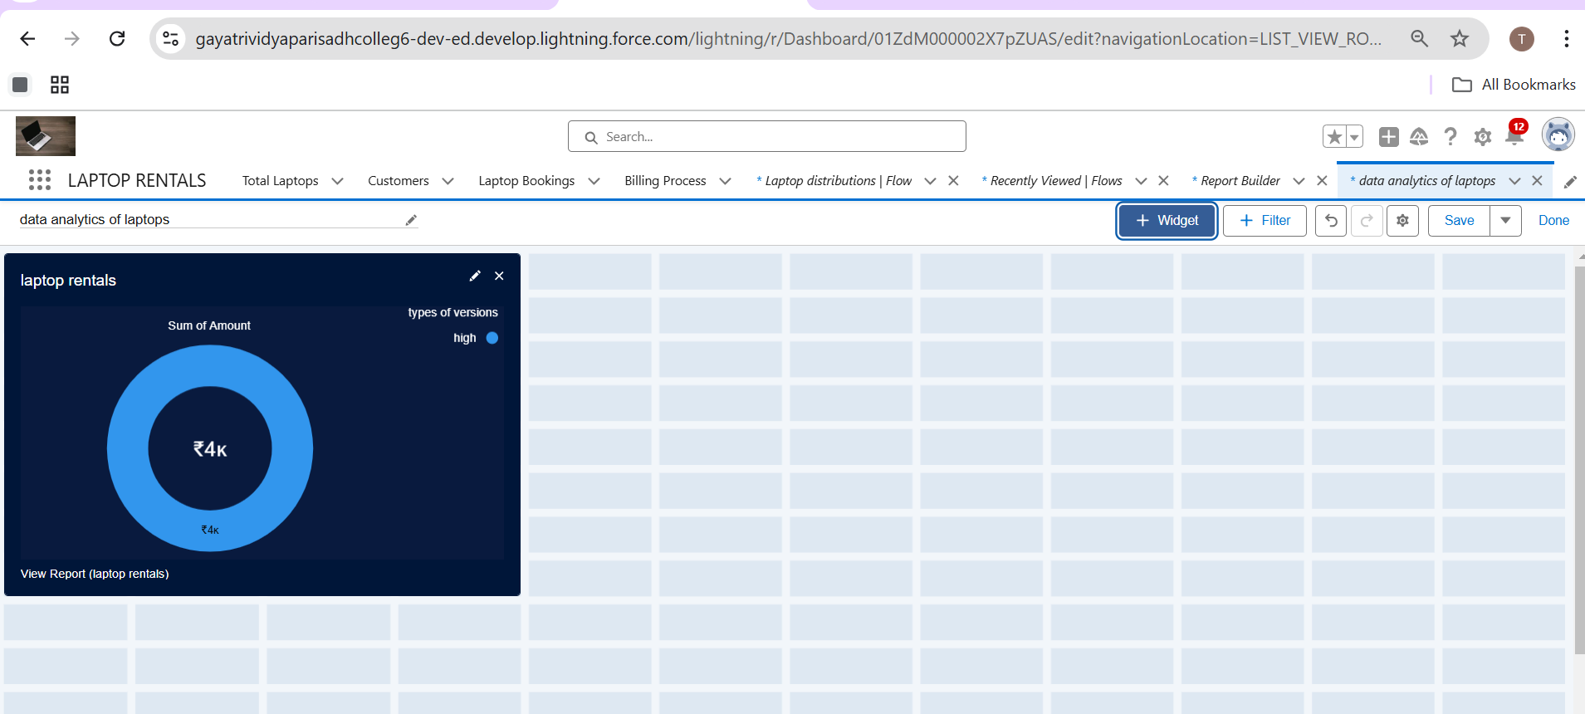

# Conclusion

The CRM application for laptop rentals successfully streamlines the rental process, from inventory management to customer relations, by leveraging Salesforce's robust capabilities. This solution has enhanced operational efficiency, improved customer experience, and ensured data accuracy. By automating and centralizing key functions, the project supports the organization’s goals of growth and high-quality service in the competitive rental market.

Salesforce URL: https://skillwallet.smartinternz.com/student/edit-profile